# GROUP 10

# INVENTION MANAGEMENT SYSTEM

# 

**RELATIONAL SCHEMA**

# INVENTOR ( INVENTOR_ID , F_NAME , L_NAME , COUNTRY , JOB_TYPE , DOB , AGE , QUALIFICATION , SPECIALIZATION_FIELD , YEAR_OF_EXPERIENCE )

INVENTION (INVENTION_ID, INVENTION_NAME, CATEGORY, YEAR_OF_INVENTION, STORY_BEHIND)

INVENTS (INVENTION_ID, INVENTOR_ID)

PANEL (PANEL_ID , YEAR, CATEGORY)

JURY (PANEL_ID, JURY_ID , JURY_NAME , QUALIFICATION , YEAR_OF_EXPERIENCE )

NOMINATIONS (PANEL_ID, INVENTION_NAME, MARKS)

AWARDS (AWARD_ID, AWARD_NAME, CATEGORY,

REWARD_AMOUNT, SPONSERED_BY)

WINNER (INVENTION_ID , PANEL_ID , AWARD_ID )

**CREATE TABLE QUERY**

**CREATE TABLE INVENTOR**

(INVENTOR_ID VARCHAR (10) PRIMARY KEY,

F_NAME VARCHAR (20),

L_NAME VARCHAR (20),

COUNTRY VARCHAR (20),

JOB_TYPE VARCHAR (20),

DOB DATE,

QUALIFICATION VARCHAR (20),

SPECIALIZATION_FIELD VARCHAR (20),

YEAR_OF_EXPERIENCE INT)

**CREATE TABLE INVENTION**

(INVENTION_ID VARCHAR (10) PRIMARY KEY,

INVENTION_NAME VARCHAR (30),

CATEGORY VARCHAR (20),

YEAR_OF_INVENTION INT,

STORY_BEHIND VARCHAR (100))

**CREATE TABLE AWARDS**

(AWARD_ID VARCHAR (10) PRIMARY KEY,

AWARD_NAME VARCHAR (20),

CATEGORY VARCHAR (20),

REWARD_AMOUNT INT,

SPONSORED_BY VARCHAR (20))

**CREATE TABLE PANEL**

(PANEL_ID VARCHAR (10) PRIMARY KEY,

CATEGORY VARCHAR (20),

YEAR INT)

**CREATE TABLE JURY**

(JURY_ID VARCHAR (10) PRIMARY KEY,

JURY_NAME VARCHAR (20),

QUALIFICATION VARCHAR (20),

YEAR_OF_EXPERIENCE INT,

PANEL_ID VARCHAR (10) REFERENCES PANEL(PANEL_ID))

**CREATE TABLE NOMINATIONS**

(INVENTION_NAME VARCHAR (30),

PANEL_ID VARCHAR (10),

MARKS INT,

PRIMARY KEY (INVENTION_NAME, PANEL_ID),

FOREIGN KEY (PANEL_ID) REFERENCES PANEL)

**CREATE TABLE INVENTS**

(INVENTION_ID VARCHAR (10) REFERENCES INVENTION(INVENTION_ID),

INVENTOR_ID VARCHAR (10) REFERENCES INVENTOR(INVENTOR_ID))

**CREATE TABLE WINNER**

(INVENTION_ID VARCHAR (10) REFERENCES INVENTION(INVENTION_ID),

AWARD_ID VARCHAR (10) REFERENCES AWARDS(AWARD_ID),

PANEL_ID VARCHAR (20) REFERENCES PANEL(PANEL_ID))

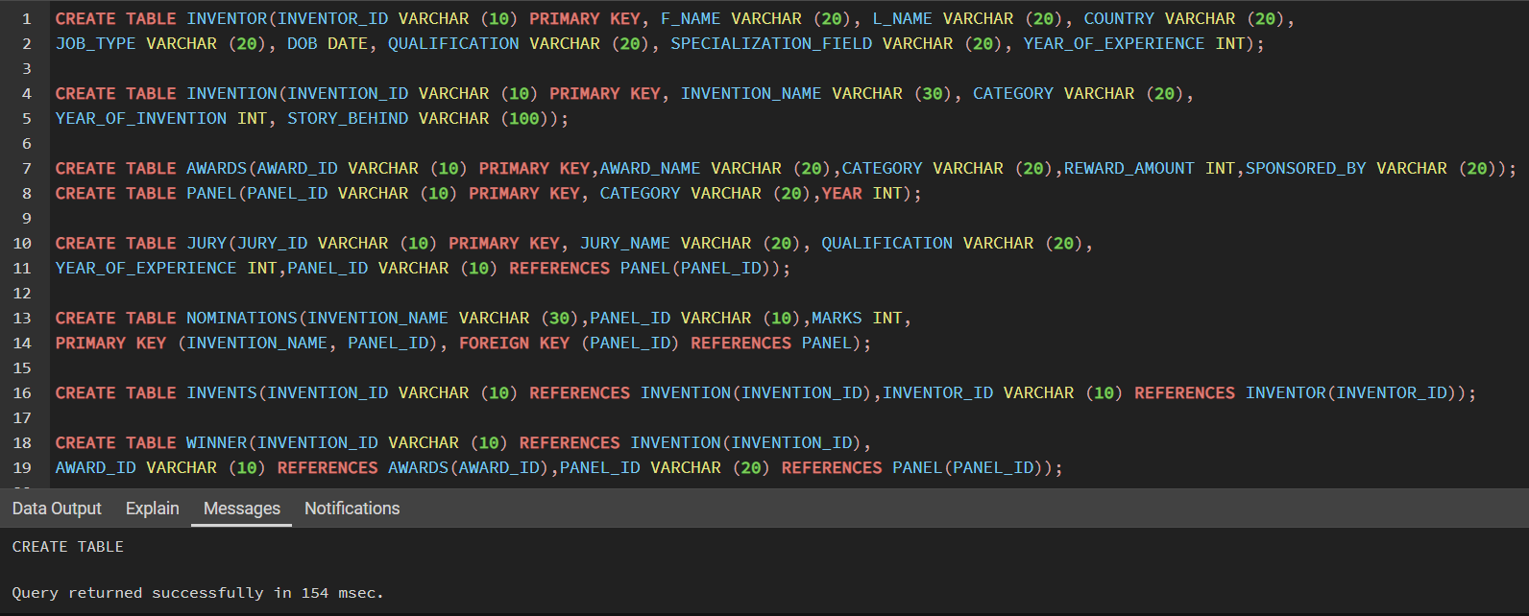

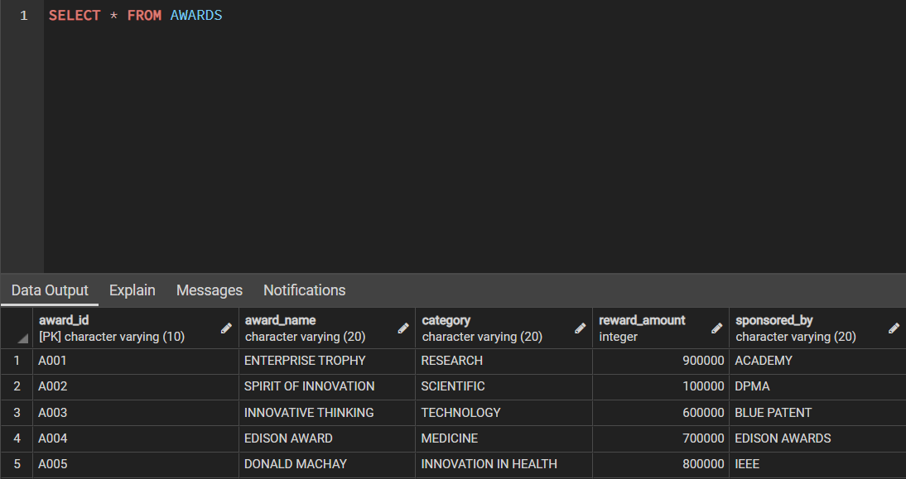

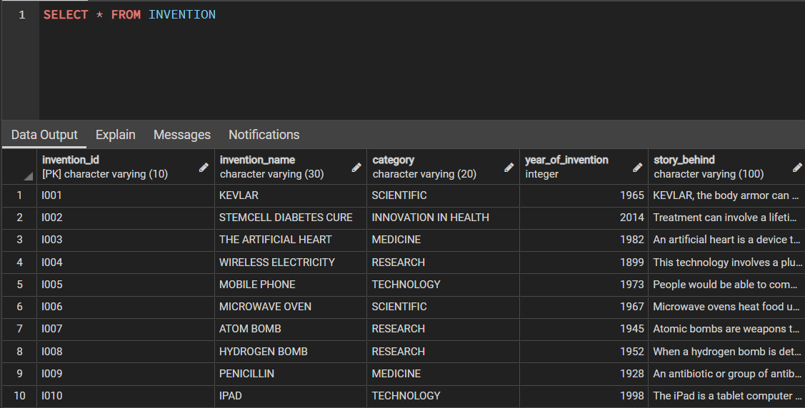

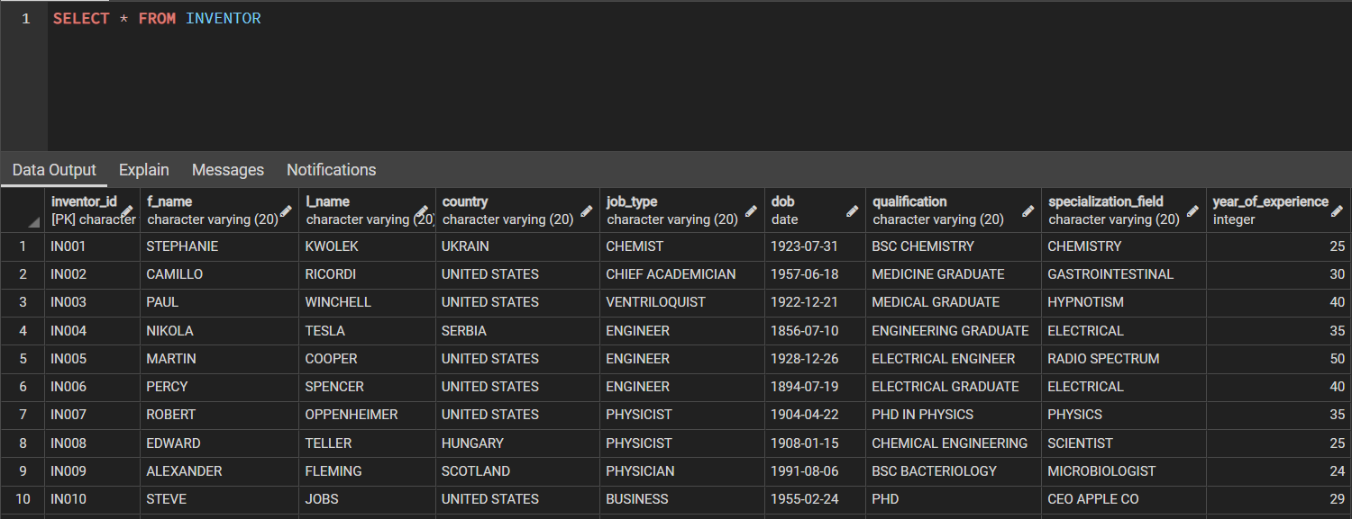

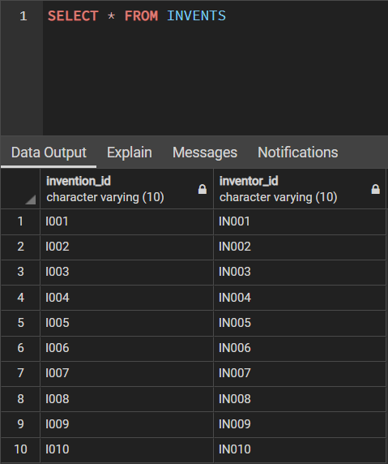

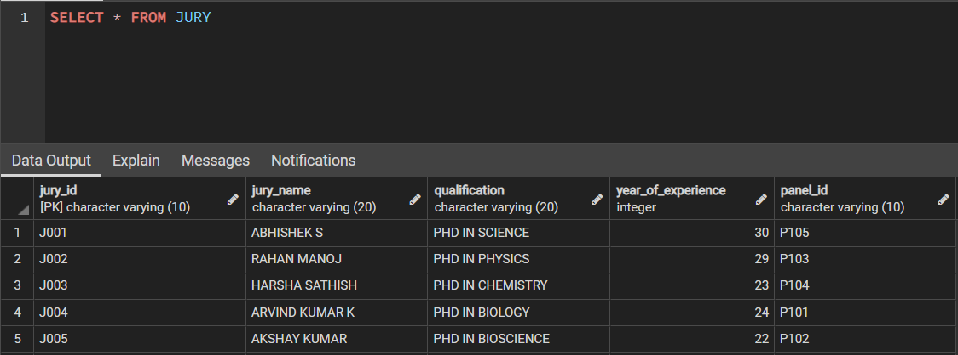

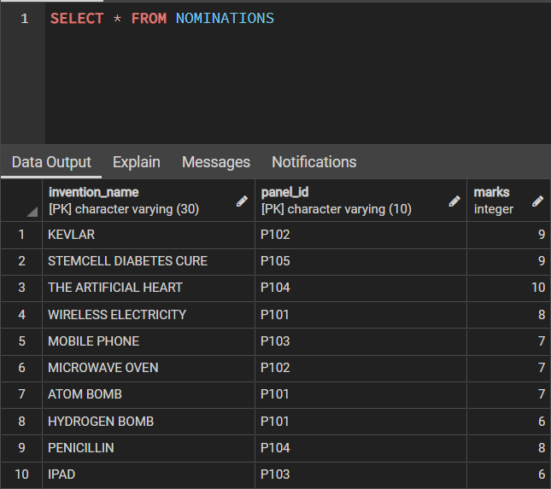

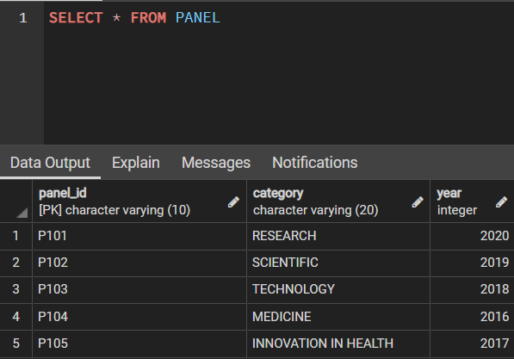

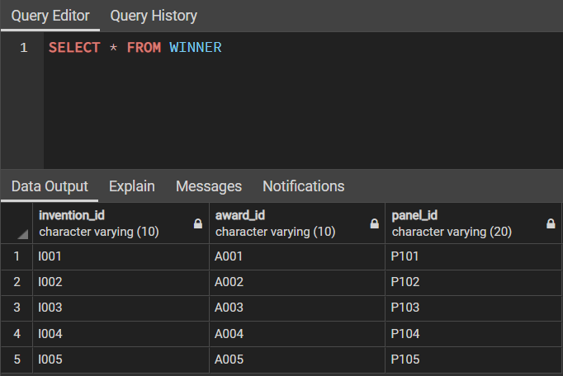

**INSERTING DATA**

**INSERT INTO INVENTOR VALUES ('IN001','STEPHANIE','KWOLEK','UKRAIN','CHEMIST','31-07-1923','BSC CHEMISTRY','CHEMISTRY',25),**

**('IN002','CAMILLO','RICORDI','UNITED STATES','CHIEF ACADEMICIAN','18-06-1957','MEDICINE GRADUATE','GASTROINTESTINAL',30),**

**('IN003','PAUL','WINCHELL','UNITED STATES','VENTRILOQUIST','21-12-1922','MEDICAL GRADUATE','HYPNOTISM',40),**

**('IN004','NIKOLA','TESLA','SERBIA','ENGINEER','10-07-1856','ENGINEERING GRADUATE','ELECTRICAL',35),**

**('IN005','MARTIN','COOPER','UNITED STATES','ENGINEER','26-12-1928','ELECTRICAL ENGINEER','RADIO SPECTRUM',50),**

**('IN006','PERCY','SPENCER','UNITED STATES','ENGINEER','19-07-1894','ELECTRICAL GRADUATE','ELECTRICAL',40),**

**('IN007','ROBERT','OPPENHEIMER','UNITED STATES','PHYSICIST','22-04-1904','PHD IN PHYSICS','PHYSICS',35),**

**('IN008','EDWARD','TELLER','HUNGARY','PHYSICIST','15-01-1908','CHEMICAL ENGINEERING','SCIENTIST',25),**

**('IN009','ALEXANDER','FLEMING','SCOTLAND','PHYSICIAN','06-08-1991','BSC BACTERIOLOGY','MICROBIOLOGIST',24),**

**('IN010','STEVE','JOBS','UNITED STATES','BUSINESS','24-02-1955','PHD ','CEO APPLE CO',29);**

* THIS QUERY IS USED TO INSERT VALUES INTO THE INVERTOR TABLE.
* THE PRIMARY KEY IS INVERTOR_ID BECAUSE IT WILL BE ONLY HAVING UNIQUE NUMBERS COMPARED TO THE OTHER ATTRIBUTES WHICH MAY BE SIMILAR
* THE ATTRIBUTES OF INVENTOR ARE:
  + - INVENTOR_ID
    - F_NAME
    - L_NAME
    - COUNTRY
    - JOB_TYPE
    - DOB DATE
    - QUALIFICATION
    - SPECIALIZATION_FIELD
    - YEAR_OF_EXPERIENCE

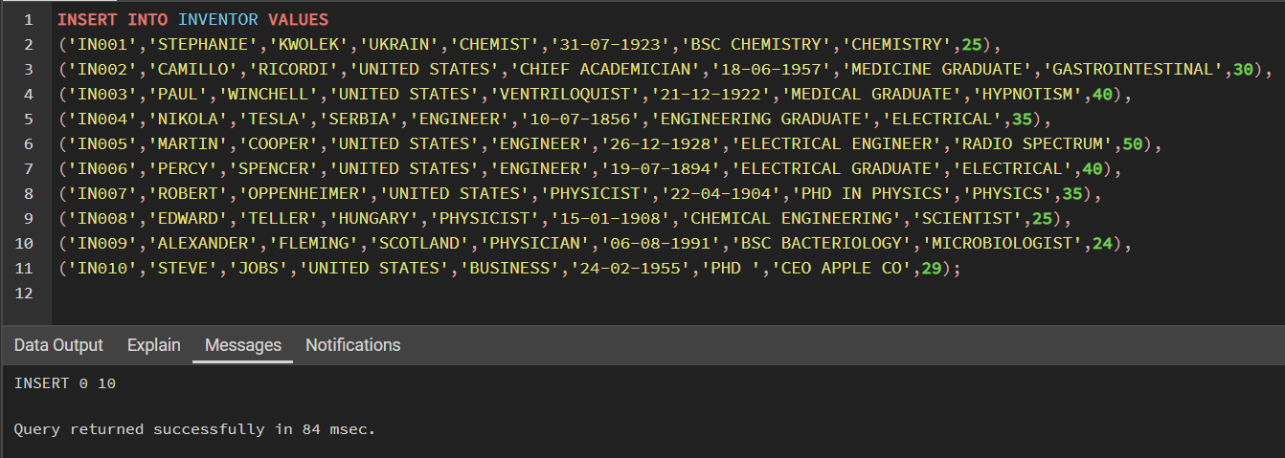

**INSERT INTO INVENTION VALUES ('I001','KEVLAR','SCIENTIFIC',1965,'KEVLAR, the body armor can protect from fatal attacks.'),**

**('I002','STEMCELL DIABETES CURE','INNOVATION IN HEALTH',2014,'Treatment can involve a lifetime of careful eating, insulin injections tests.'),**

**('I003','THE ARTIFICIAL HEART','MEDICINE',1982,'An artificial heart is a device that replaces the heart.'),**

**('I004','WIRELESS ELECTRICITY','RESEARCH',1899,'This technology involves a plug-in coil that creates a magnetic field.'),**

**('I005','MOBILE PHONE','TECHNOLOGY',1973,'People would be able to communicate free of the restriction of wires and cables.'),**

**('I006','MICROWAVE OVEN','SCIENTIFIC',1967,'Microwave ovens heat food using microwaves, a form of electromagnetic radiation.'),**

**('I007','ATOM BOMB','RESEARCH',1945,'Atomic bombs are weapons that get their energy from fission reactions.'),**

**('I008','HYDROGEN BOMB','RESEARCH',1952,'When a hydrogen bomb is detonated, the immediate effects are devastating.'),**

**('I009','PENICILLIN','MEDICINE',1928,'An antibiotic or group of antibiotics produced naturally by certain blue moulds.'),**

**('I010','IPAD','TECHNOLOGY',1998,'The iPad is a tablet computer developed by Apple.');**

* THIS QUERY IS USED TO INSERT VALUES INTO THE INVENTION TABLE
* THE PRIMARY KEY IS INVENTION_ID AS IT IS INDIVIDUAL AND PECULIAR.
* THE ATTRIBUTES OF INVENTION ARE:
  + INVENTION_ID
  + INVENTION_NAME
  + CATEGORY
  + YEAR_OF_INVENTION
  + STORY_BEHIND

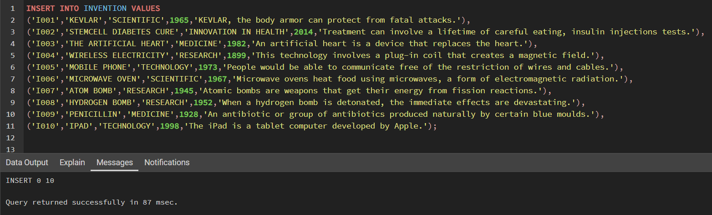

**INSERT INTO AWARDS VALUES**

**('A001','ENTERPRISE TROPHY','RESEARCH',900000,'ACADEMY'),**

**('A002','SPIRIT OF INNOVATION','SCIENTIFIC',100000,'DPMA'),**

**('A003','INNOVATIVE THINKING','TECHNOLOGY',600000,'BLUE PATENT'),**

**('A004','EDISON AWARD','MEDICINE',700000,'EDISON AWARDS'),**

**('A005','DONALD MACHAY','INNOVATION IN HEALTH',800000,'IEEE');**

* THIS QUERY IS USED TO INSERT VALUES INTO THE AWARDS TABLE.
* THE PRIMARY KEY IS AWARD_ID BECAUSE IT WILL BE UNIQUE COMPARED TO AWARD_NAME BECAUSE AWARD_NAME CAN BE SAME.
* THE ATTRIBUTES OF AWARDS ARE:
* AWARD_ID
* AWARD_NAME
* CATEGORY
* REWARD_AMOUNT
* SPONSORED_BY

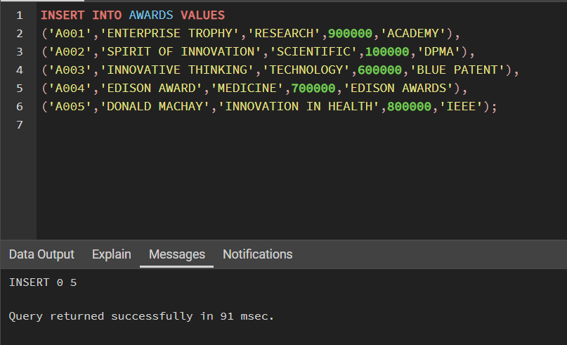

**INSERT INTO PANEL VALUES**

**('P101','RESEARCH',2020),**

**('P102','SCIENTIFIC' ,2019),**

**('P103','TECHNOLOGY',2018),**

**('P104','MEDICINE',2016),**

**('P105','INNOVATION IN HEALTH',2017);**

* THIS QUERY IS USED TO INSERT VALUES INTO THE PANEL TABLE
* THE PRIMARY KEY IS PANEL_ID BECAUSE IT IS THE ONE WHICH IS UNIQUE FROM THE ABOVE ATTRIBUTES
* THE ATTRIBUTES OF PANEL ARE
  + - PANEL_ID
    - CATEGORY
    - YEAR

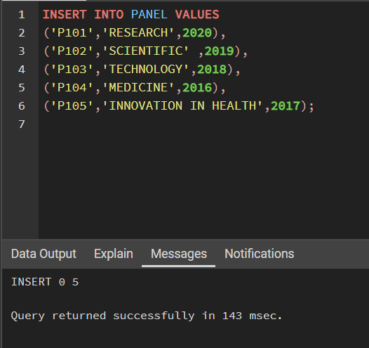

**INSERT INTO JURY VALUES**

**('J001','ABHISHEK S','PHD IN SCIENCE',30,'P105'),**

**('J002','RAHAN MANOJ','PHD IN PHYSICS' ,29,'P103'),**

**('J003','HARSHA SATHISH','PHD IN CHEMISTRY',23,'P104'),**

**('J004','ARVIND KUMAR K','PHD IN BIOLOGY',24,'P101'),**

**('J005','AKSHAY KUMAR','PHD IN BIOSCIENCE',22,'P102');**

* THIS QUERY IS USED TO INSERT VALUES INTO THE JURY TABLE.
* THE PRIMARY KEY IS JURY_ID AS JURY MAY CONTAIN MANY REPEATED NAMES HERE ID IS BEING SELECTED AS PRIMARY KEY
* THE ATTRIBUTES OF JURY ARE:
  + JURY_ID
  + JURY_NAME
  + QUALIFICATION
  + YEAR_OF_EXPERIENCE
  + PANEL_ID - REFERENCES PANEL(PANEL_ID)

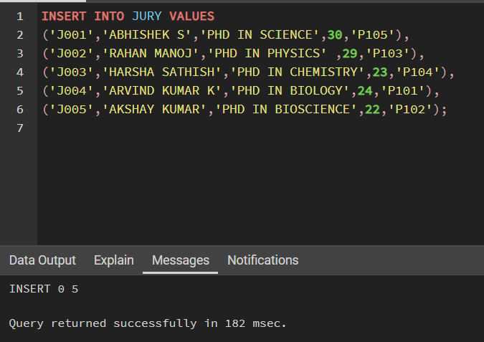

**INSERT INTO INVENTS VALUES ('I001','IN001'),**

**('I002','IN002'), ('I003','IN003'),('I004','IN004'),('I005','IN005'),**

**('I006','IN006'), ('I007','IN007'),('I008','IN008'),('I009','IN009'),**

**('I010','IN010');**

* THIS QUERY IS USED TO INSERT VALUES INTO THE INVENTS TABLE.
* THE ATTRIBUTES OF INVENTS ARE:
  + INVENTION_ID - REFERENCES INVENTION(INVENTION_ID)
  + INVENTOR_ID - REFERENCES INVENTOR(INVENTOR_ID)

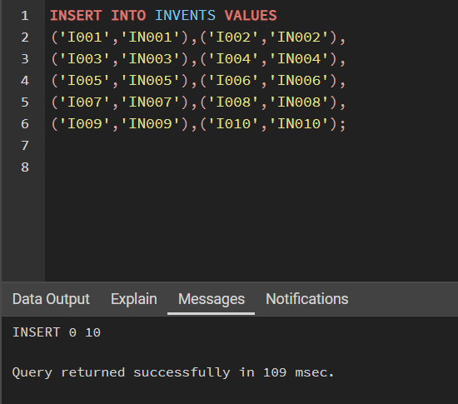

**INSERT INTO NOMINATIONS VALUES**

**('KEVLAR', 'P102' ,9),**

**('STEMCELL DIABETES CURE', 'P105' , 9),**

**('THE ARTIFICIAL HEART', 'P104' ,10),**

**('WIRELESS ELECTRICITY', 'P101' ,8),**

**('MOBILE PHONE', 'P103', 7),**

**('MICROWAVE OVEN', 'P102' ,7),**

**('ATOM BOMB', 'P101', 7),**

**('HYDROGEN BOMB', 'P101',6),**

**('PENICILLIN', 'P104', 8),**

**('IPAD’, 'P103' ,6);**

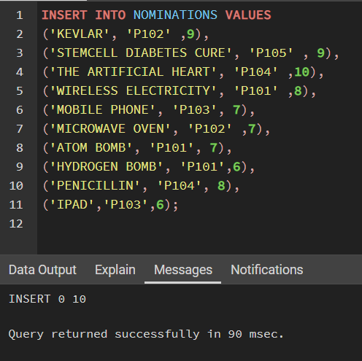

**INSERT INTO WINNER VALUES**

**('I001','A001','P101',),**

**('I002','A002','P102'),**

**('I003','A003','P103'),**

**('I004','A004','P104'),**

**('I005','A005','P105');**

* THIS QUERY IS USED TO INSERT VALUES INTO THE WINNER TABLE
* THE ATTRIBUTE OF WINNER ARE:
  + INVENTION_ID - REFERENCES INVENTION(INVENTION_ID)
  + AWARD_ID - REFERENCES AWARDS(AWARD_ID)
  + PANEL_ID - REFERENCES PANEL(PANEL_ID))

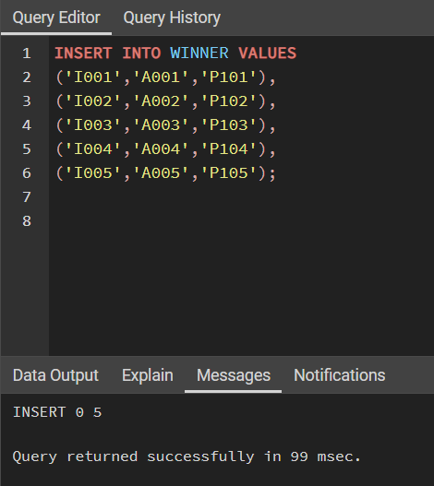

**QUERIES**

* **SELECT CATEGORY, COUNT (*) FROM INVENTION GROUP BY CATEGORY HAVING COUNT (*) > 1;**

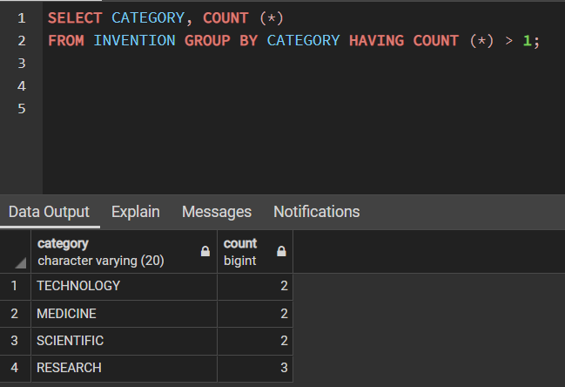

* This query is used to view the count of the Inventions which belongs to the same category with count greater than 1.
* **SELECT * FROM INVENTOR ORDER BY F_NAME;**

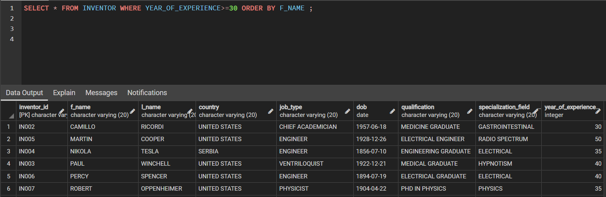

* This query is used to select all the tuples of INVENTOR table which is sorted alphabetically with respect to F_NAME and having more than 30 or more years’ experience.
* **SELECT INVENTION_NAME, F_NAME || ' ' || L_NAME AS INVENTOR_NAME, CATEGORY FROM INVENTION NATURAL JOIN INVENTOR NATURAL JOIN INVENTS;**

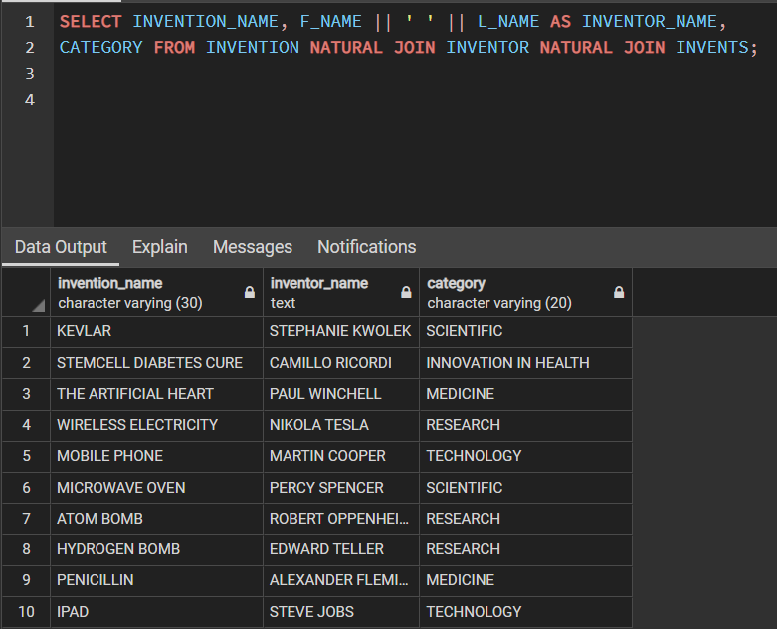

* This query is used to obtain Inventor Name and the name of their Inventions along with its category.
* **SELECT MAX(REWARD_AMOUNT), COUNT(INVENTION_ID), CATEGORY FROM AWARDS NATURAL JOIN INVENTION GROUP BY CATEGORY HAVING MAX(REWARD_AMOUNT) =**

**(SELECT MAX(REWARD_AMOUNT) FROM AWARDS)**

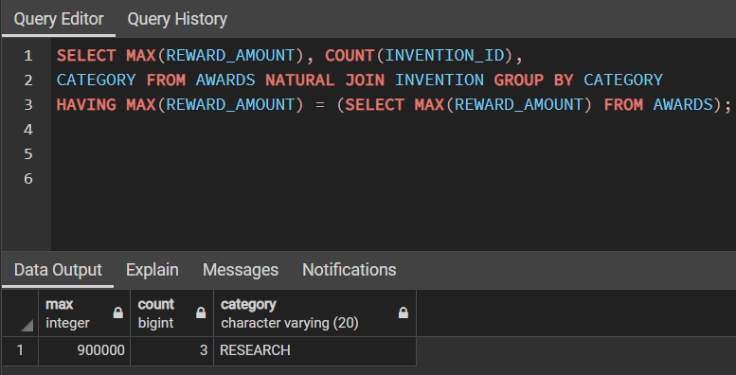

* This query is used to obtain the maximum reward amount among all inventions and the number of inventions which received the maximum reward amount along with its category.

* **SELECT * FROM AWARDS WHERE REWARD_AMOUNT>100000 AND REWARD_AMOUNT<900000**

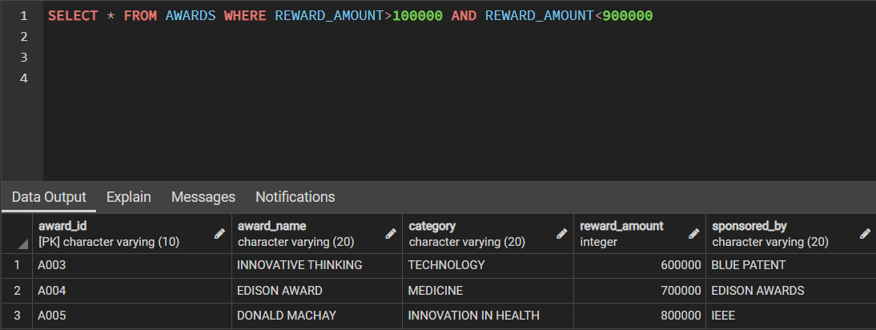

* This query displays details of all awards whose reward amount is more than 100000 and less than 900000.
* **SELECT AWARD_NAME, CATEGORY, REWARD_AMOUNT, REWARD_AMOUNT*15/100 AS CHARITY_AMOUNT, REWARD_AMOUNT-REWARD_AMOUNT*15/100 AS AMOUNT_RECEIVED FROM AWARDS WHERE REWARD_AMOUNT*15/100>80000 AND REWARD_AMOUNT-REWARD_AMOUNT*15/100>550000**

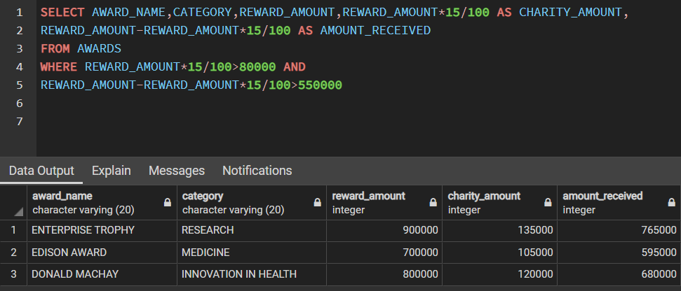

* In this query, 15% of REWARD_AMOUNT is given as CHARITY_AMOUNT.
* 100-15 = 85% is taken as AMOUNT_RECEIVED
* This query displays AWARD_NAME, CATEGORY of AWARDS table whose CHARITY_AMOUNT > 80000 and AMOUNT_RECIEVED > 550000.
* **SELECT CONCAT (F_NAME,' ', L_NAME) AS NAME, COUNTRY, JOB_TYPE FROM INVENTOR WHERE LEFT(COUNTRY,1) ='U' AND RIGHT(JOB_TYPE,1) ='T'**

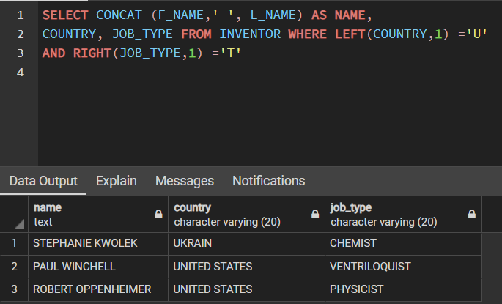

* In this query, first we concatenate the F_NAME and L_NAME separated by a space and it is renamed as NAME.
* We obtain the NAME along with the COUNTRY and JOB_TYPE of the inventor whose COUNTRY starts with ‘U’ and JOB_TYPE ends with ‘T’.
* **SELECT F_NAME, DOB, TO_CHAR(DOB,'DAY') AS DAY_NAME, TO_CHAR(DOB,'DD') AS DAY_OF_MONTH, TO_CHAR(DOB,'MONTH') AS MONTH, EXTRACT (YEAR FROM DOB) AS YEAR FROM INVENTOR**

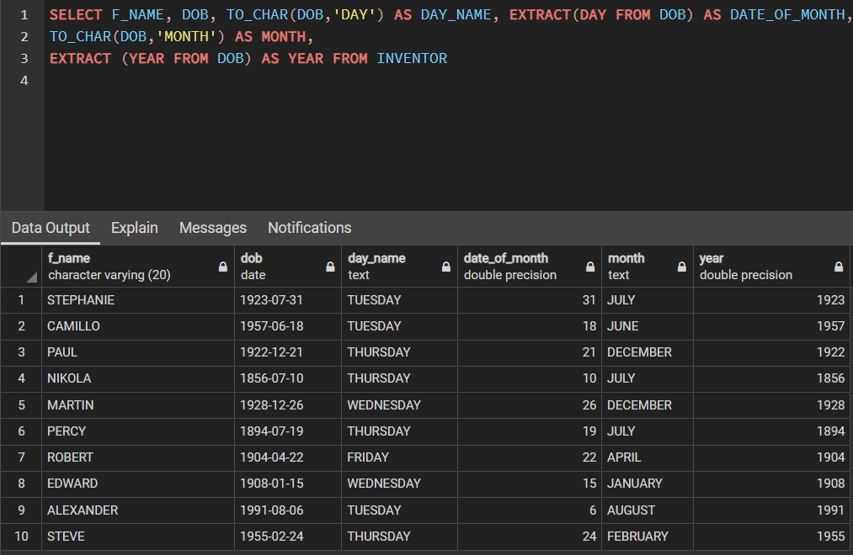

* It obtains the F_NAME, DOB, name of the day, date of the month, name of the month and the year in which the Inventor born.
* **SELECT * FROM INVENTION WHERE CATEGORY IN ('RESEARCH','MEDICINE','TECHNOLOGY') AND YEAR_OF_INVENTION BETWEEN 1950 AND 2000**

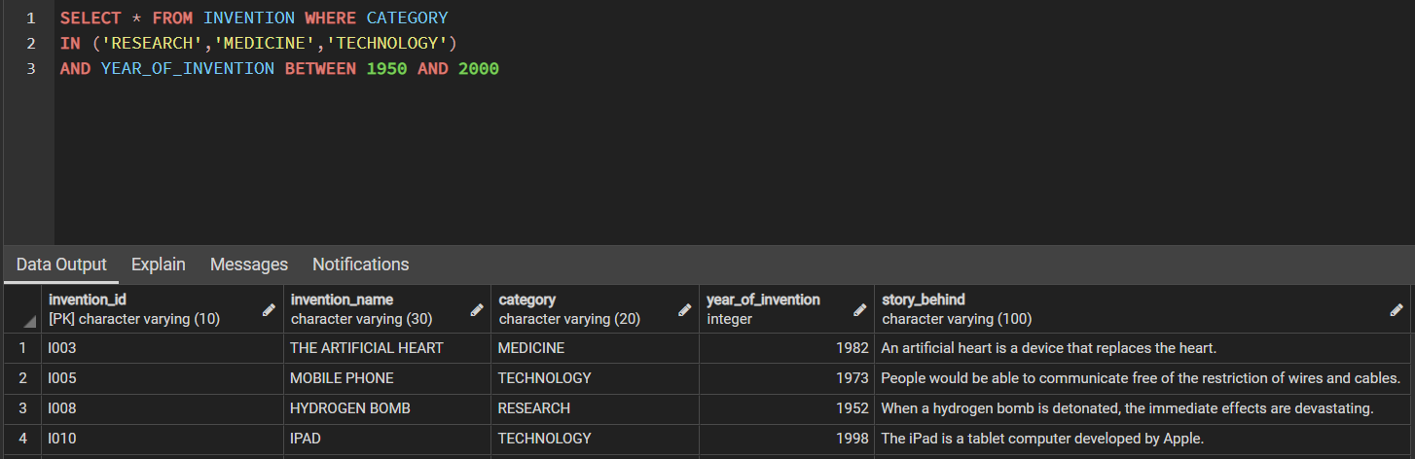

* This query selects all the tuples from the INVENTION table whose CATEGORY is one among RESEARCH, MEDICINE, TECHNOLOGY and the YEAR_OF_INVENTION should be in between 1950 and 2000.
* **SELECT * FROM INVENTION WHERE CATEGORY NOT IN('MEDICINE','TECHNOLOGY') AND YEAR_OF_INVENTION NOT BETWEEN 1950 AND 2000**

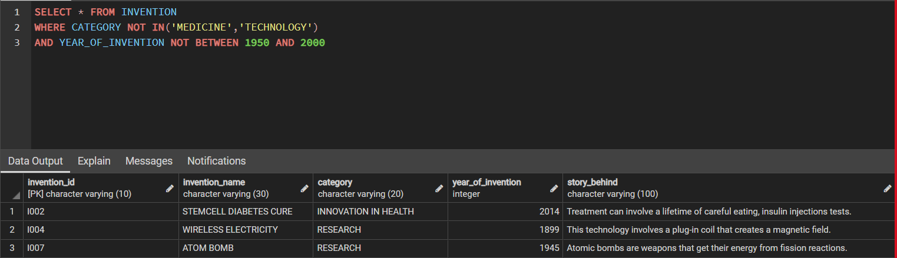

* This query selects all the tuples from INVENTION table whose CATEGORY is not MEDICINE and TECHNOLOGY and the YEAR_OF_INVENTION should not be in between 1950 and 2000.
* **SELECT * FROM INVENTOR WHERE DOB BETWEEN '1950-01-01' AND '2000-01-01' UNION SELECT * FROM INVENTOR WHERE YEAR_OF_EXPERIENCE BETWEEN 20 AND 25;**

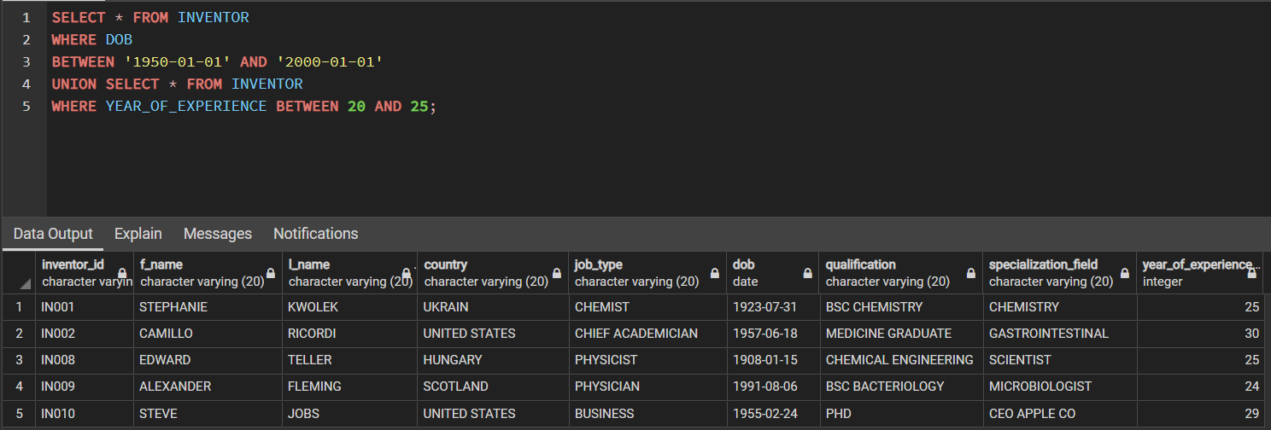

* This query selects all the tuples from INVENTOR table whose DOB should be in between 1st January 1950 and 1st January 2000 and we also select all tuples from INVENTOR whose YEAR_OF_EXPERIENCE should be in between 20 and 25.
* We use UNION to combine these 2 select queries, where any duplicate row will be removed.
* **SELECT * FROM INVENTION WHERE CATEGORY='RESEARCH' INTERSECT SELECT * FROM INVENTION WHERE YEAR_OF_INVENTION BETWEEN 1900 AND 2000;**

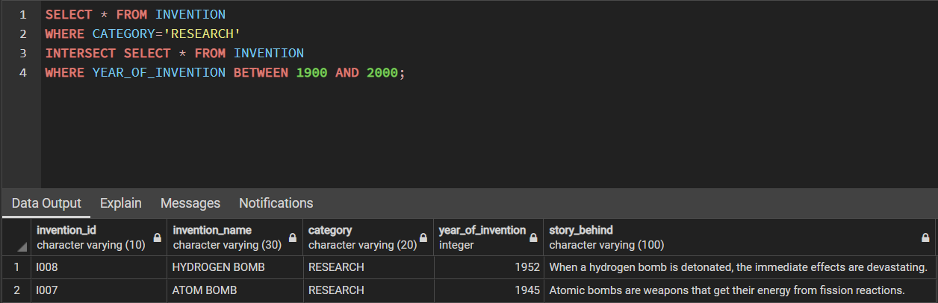

* This query displays all data from INVENTION whose CATEGORY is RESEARCH and YEAR_OF_INVENTION is in between 1900 and 2000.
* Here, INTERSECT is used to join the 2 select queries, but only the common tuples are returned.
* **SELECT * FROM INVENTION WHERE CATEGORY IN('RESEARCH','MEDICINE','TECHNOLOGY') EXCEPT SELECT * FROM INVENTION WHERE YEAR_OF_INVENTION > 1950;**

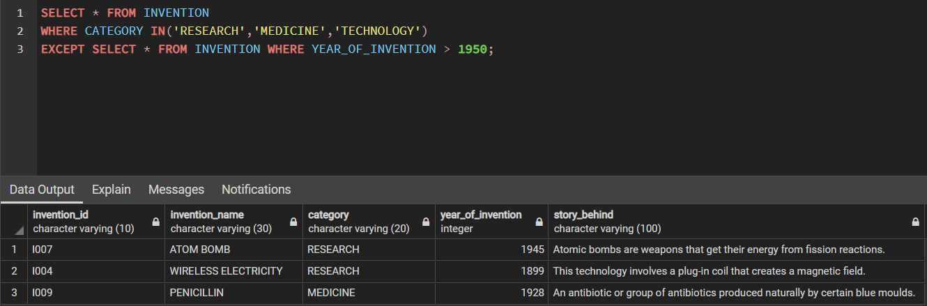

* This query selects all the tuples from INVENTION whose CATEGORY is one among RESEARCH, MEDICINE, TECHNOLOGY and the YEAR_OF_INVENTION should not be >1950.
* The EXCEPT operator returns distinct rows from the first (left) query that are not in the output of the second (right) query.

**THANK YOU!!**

**DONE BY**

RAHAN MANOJ - AM.EN.U4CSE19144

HARSHA SATHISH - AM.EN.U4CSE19123

ARVIND KUMAR K - AM.EN.U4CSE19109

S. ABHISHEK - AM.EN.U4CSE19147